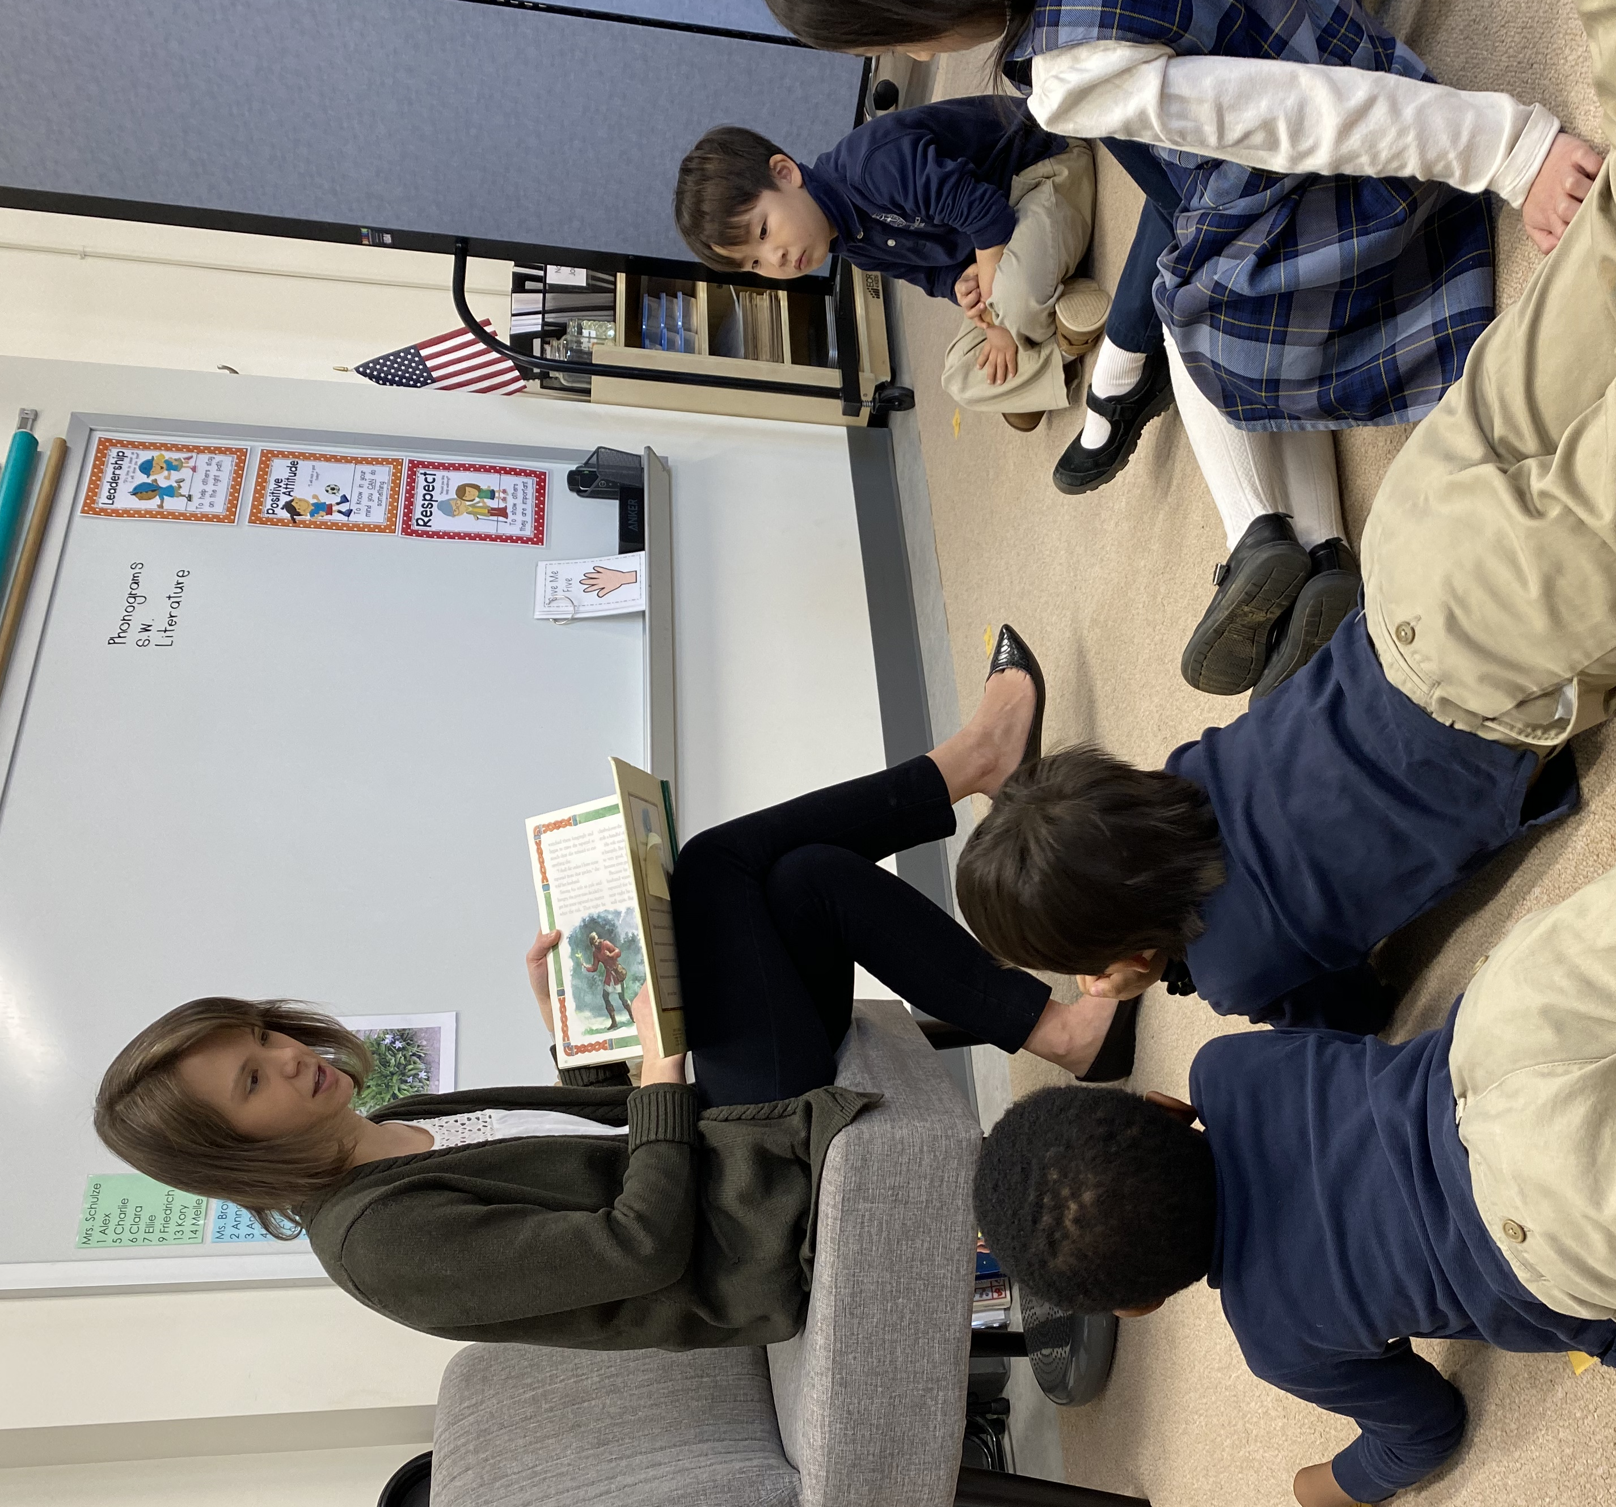
February is Reading Rally month at The Wilberforce School. During Reading Rally, we challenge ourselves to read more than usual, to meet new authors, and to discover different genres. By the end of the month, each student seeks to meet an impressive reading goal.
Now that we have a new Lower School library, we decided to start a new tradition – highlighting one literary genre each Reading Rally. We hope that this tradition will help our students to become more familiar with our library's contents. This year, we are focusing on biography/autobiography, and our library shelves will prominently feature books in this genre. We expect that reading biographies will expand our students' knowledge not only of individuals and history but also of the vast areas where they may someday affect the world for God's Kingdom.
Another goal of Reading Rally is to ask family and friends to sponsor our students. As students pledge to meet reading goals, sponsors pledge to donate money to our school. As you consider supporting the reading efforts of our students, know that you are investing in classrooms that reflect our love for learning, love for literature, and love for students. How will you partner with us in this endeavor? Thank you for partnering with us!
Last year we raised $2,300 toward the purchase of books and library furniture. This year we are hoping to fill classroom library shelves and to complete the MPR library with shelf markers.
Become a sponsor by giving online (wilberforceschool.org under the “Giving” tab) OR by submitting a donation with this form:
$25
$50
$150
Other $_______________
Name of student(s) you are sponsoring:
Student 1 ________________________________ Grade ____________
Student 2 ________________________________ Grade ____________
Student 3 ________________________________ Grade ____________
Student 4 ________________________________ Grade ____________

In an envelope, enclose this form with cash or a check (payable to “The Wilberforce School,” with “Reading Rally” on the memo line). Please give the donation envelope to the student, or mail it directly to our school by Friday, March 27: The Wilberforce School | Business Office | 75 Mapleton Rd | Princeton, NJ 08540
*A tax deductible receipt will be issued for donations $20 and over. To receive a receipt, please supply a full mailing address below.
Your name: _____________________________
Mailing address: __________________________________________________________
Email: __________________________________________________________

